Since there’s a limit to what can be written into the chat bot, I shall be using this word docx for a series of things I want to implement or change.

Guidelines when refactoring the codes:
- Ensure performance of the system, operational efficiency, and user experience (whether they are either guests, receptionists, or admin) as priority.
- For example, ease of use, easy to understand, guarantee productivity, and profitability.

1. When rendered in the browser, in the rooms page, remove the “Details” button, keeping only the “Book” button since these two basically lead to the same page.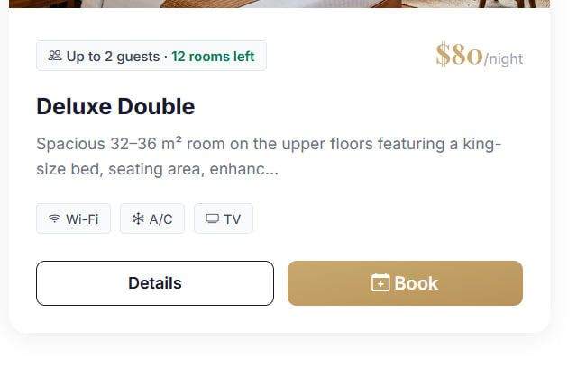
2. When inputting booking detail, there should be optional options to choose which floor they want, and a dropdown on whether they want either balcony view, window view, or not. Obviously, if it’s not available, guests should be informed immediately that the rooms aren’t available without having to click the proceed to payment button.

3. In payment page, Remove this 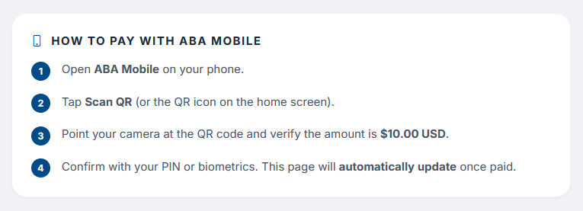

4. Hide payment method on guest side and payment method management on admin side. Allow guests to proceed to payment without having to choose payment method. Don’t change anything in the code base.

5. In this page, the adults and children don’t need dropdown. Instead, it should just tell the guests plainly about the room’s occupancy. 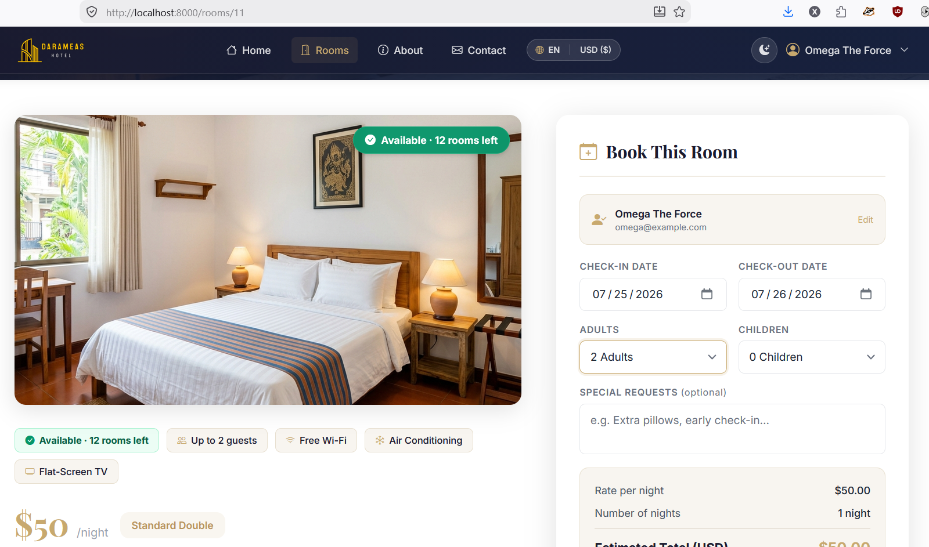
- Standard Room will have occupancy limit for 2 adults and 1 child under age 12, and bed type dropdown that shows Twin or Double.
- Deluxe Room will have occupancy limit for 2 adults and 1 child under age 12, and bed type dropdown that shows Twin or Double.
- Family Triple Room will have occupancy limit for 2 adults and 2 children under age 12.

6. Relevant to point 5, in home page, this box should have adults and children dropdown which will filter the room type. Add an optional dropdown for whether they want either balcony view, window view, or not. Then, remove room type dropdown. Obviously, the system will remember guests’ data inputs.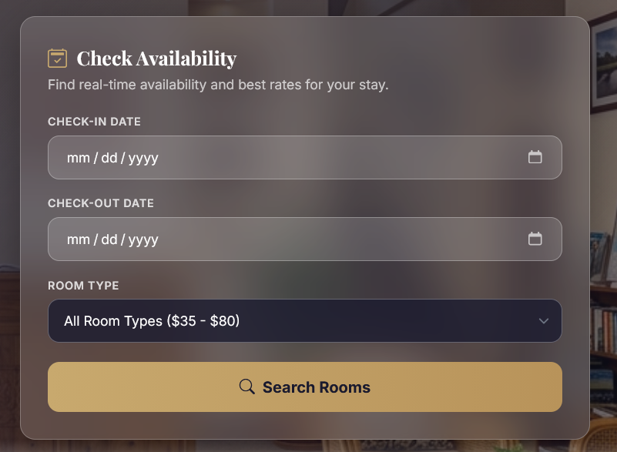
Template for adults and children dropdown.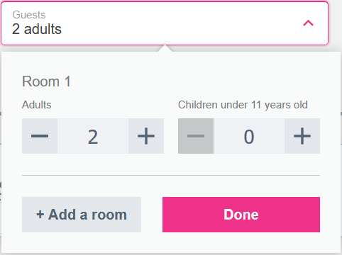

7. Similar to point 5 and 6, instead of room type dropdown, replace it with adults and children dropdown.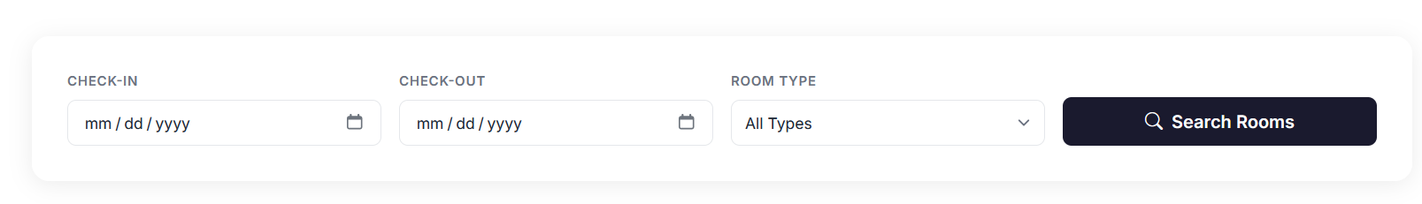

8. In the PRIME LOCATION & NEIGHBORHOOD GUIDE section, change these parts. Our location is in street 2004 of Sen Sok so makes changes accordingly.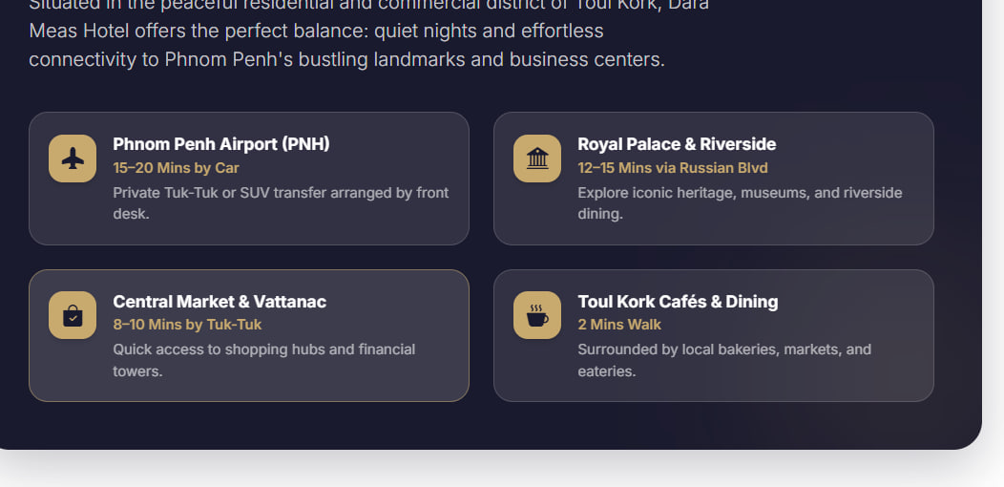

9. Hide the Price unit change button in the header from now on.  The reason is because we use static QR codes. Don’t remove it from the codebase.

10. Remove the ABA Tran ID in payment page. 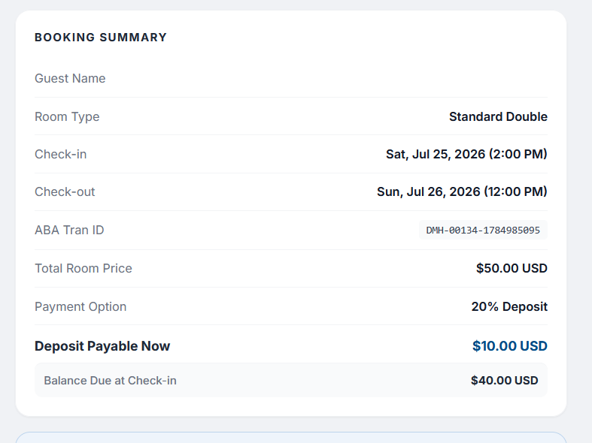

11. Consider printing receipt during a scenario of completing a transaction in front of the receptionist such as the rare walk-in guests who want to book first, and guests who have arrived and are needed to be checked in.
Here is the receipt inspiration.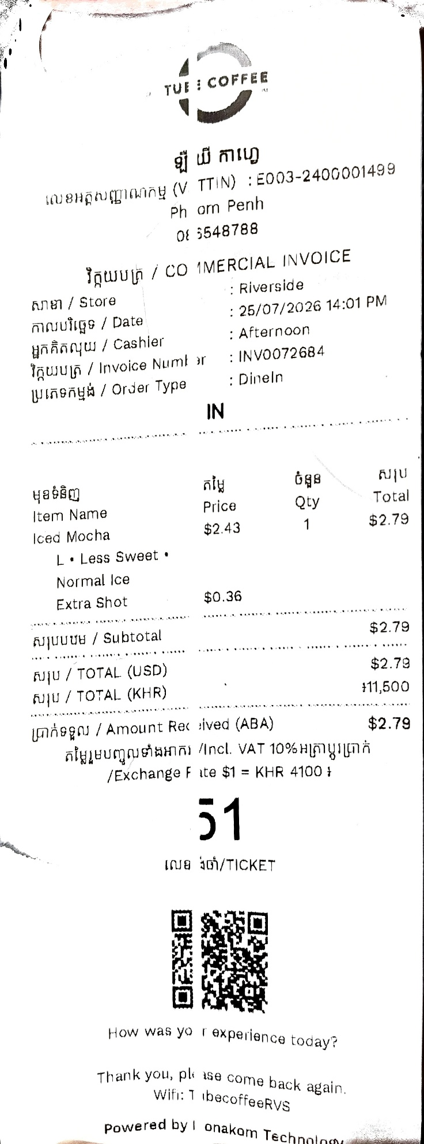 Remove unrelated stuff and keep those that should be kept.

